TITLE: DESIGN AND APPLY CONTEXT-AWARE ACCESS CONTROLS BASED ON USER IDENTITY, DEVICE POSTURE, LOCATION, AND APPLICATION RISK.

COLLEGE NAME: KPR COLLEGE OF ARTS SCIENCE AND RESEARCH
DEPARTMENT: B.Sc. COMPUTER SCIENCE WITH DATA ANALYTICS

TEAM MEMBERS:
SNO | REGISTER NUMBER | NAME | COLLEGE | MAIL ID
1 | 2328B0062 | RUBIHA M (TEAM LEADER) | KPRCAS | 23bda052@kprcas.ac.in
2 | 2328B0048 | MUKESH S | KPRCAS | 23bda038@kprcas.ac.in
3 | 2328B0053 | PON NISHANDHINI S | KPRCAS | 23bda043@kprcas.ac.in
4 | 2328B0058 | PREETHI S | KPRCAS | 23bda048@kprcas.ac.in
5 | 2328B0061 | RITHIKA B | KPRCAS | 23bda051@kprcas.ac.in

USE CASE SCENARIOS
- Employee Accessing Internal Application
In this scenario, an employee attempts to access an internal company application from a corporate laptop within the office network. The system verifies the user's identity through authentication and checks the security posture of the device. Since the device is secure and the user belongs to the authorized group, the system grants access to the required application. Other internal systems remain hidden and inaccessible to maintain least-privilege access.
- Contractor Accessing Project Repository
A temporary contractor needs access to a specific project repository hosted on the company server. The contractor is assigned limited permissions and is allowed to access only the required application. The system checks the user’s role, device status, and access time. Access is granted only during authorized working hours and only to the specific repository, preventing unauthorized access to other systems.
- Executive Accessing Sensitive Data from Remote Location
An executive user attempts to access confidential financial documents while traveling. The system verifies the user identity and device security but detects that the login request is coming from an unusual geographic location. Due to the increased risk level, the system enforces additional security measures such as multi-factor authentication and restricts actions like downloading or printing sensitive documents.
- IT Support Accessing Administrative Tools
An IT support technician needs access to internal tools to assist employees. The system checks the technician’s identity, device compliance, and authorized role. If the device meets security requirements and the user belongs to the IT support group, the system grants access only to the necessary support tools while restricting access to other critical systems.

- User Access from Public Network
A user attempts to access a company application from a public Wi-Fi network. Even though the user is authenticated and using a registered device, the system identifies the network as high risk. Instead of allowing direct access, the system provides restricted access through a secure session to protect sensitive data and prevent possible attacks.
STAGE 1
ABSTRACT
With the rapid growth of digital technologies, organizations increasingly rely on web applications and online systems to store and process sensitive information. However, these systems are often targeted by cyber attackers who attempt to exploit security weaknesses. Traditional security methods that rely only on simple authentication mechanisms are no longer sufficient to protect modern applications.
This project focuses on designing and applying context-aware access control mechanisms based on user identity, device posture, location, and application risk. The objective of this approach is to improve the security of web applications by evaluating multiple contextual factors before granting access to users.
In addition to implementing access control concepts, vulnerability assessment and security testing were performed on target web applications using cybersecurity tools such as Nessus Scanner, Burp Suite, and Kali Linux. The testing process helped identify various vulnerabilities including Cross-Site Scripting, information exposure issues, and outdated software components.
The results obtained from the vulnerability analysis highlight potential security risks and demonstrate the importance of implementing proper security mechanisms such as input validation, secure configuration, and regular vulnerability scanning. This project emphasizes the role of modern security practices and context-aware access control in protecting systems from cyber threats and improving overall application security.

INTRODUCTION
In today’s interconnected digital world, web applications and online systems play a crucial role in business operations, communication, and data management. As organizations increasingly adopt cloud computing, remote work environments, and mobile devices, the traditional concept of network security boundaries has significantly changed. These changes have created new challenges in protecting sensitive data and preventing unauthorized access.
Cyber attackers continuously attempt to exploit vulnerabilities present in web applications and servers. Weak authentication systems, improper input validation, and poor configuration settings can lead to serious security issues such as data breaches, unauthorized access, and system compromise. Therefore, it is important to implement advanced security mechanisms that can effectively protect applications and digital assets.
This project introduces the concept of context-aware access control, which is a modern security approach that evaluates different contextual factors before granting access to a system. Instead of relying only on usernames and passwords, the system analyzes additional parameters such as user identity, device security posture, geographical location, and the risk level of the application being accessed.
Along with implementing access control concepts, the project also focuses on vulnerability assessment and security testing. Various cybersecurity tools such as Nessus Scanner, Burp Suite, and Kali Linux were used to identify security weaknesses in the target web application. The vulnerabilities detected during the scanning process were analyzed to understand their potential impact and security risks.
By combining context-aware access control and vulnerability analysis, this project aims to improve the security posture of web applications and demonstrate the importance of proactive cybersecurity practices in protecting modern digital environments.

OVERVIEW:
In today's digital environment, organizations face many cybersecurity threats when users access systems from different locations and devices. Traditional security methods that only rely on usernames and passwords are no longer sufficient to protect sensitive data.
This project focuses on designing and applying context-aware access control, which is a modern security approach that evaluates multiple factors before allowing access to an application. These factors include the user's identity, the security condition of the device, the location from which the user is accessing the system, and the risk level of the application.
The system analyzes these conditions in real time and decides whether to allow access, restrict certain actions, request additional authentication such as multi-factor authentication (MFA), or block the access completely.
The goal of this project is to improve cybersecurity by implementing a Zero Trust security model, where every access request is verified before granting permission. This helps organizations protect sensitive data, prevent unauthorized access, and ensure secure usage of applications from any device or location.
SNO | VULNERBILITY NAME | CWE NO
1 | Cross Site Scripting (Stored) | CWE-79
2 | Broken Access Control | CWE-285
3 | SQL Injection | CWE- 89
4 | Broken Authentication | CWE- 285
5 | Insecure Direct Object Reference | CWE- 639
6 | Security Misconfiguration | CWE- 732
7 | Cross Site Request Forgery | CWE- 352
8 | Cleartext Transmission of Sensitive Information | CWE- 319
9 | Clickjacking | CWE-1021
10 | Password Auto Completion Enabled | CWE- 310
11 | DOM Based Cross Site Scripting | CWE-79
12 | JQuery Multiple XSS | CWE- 79
13 | Information Exposure (HTTP Header Internal IP Disclosure) | CWE- 200
14 | Information Exposure (SSL Issues) | CWE- 200
15 | Information Exposure (HTTP Issues) | CWE- 200
16 | OS Identification Failed | CWE- 200

- Vulnerability Name: Cross-Site Scripting (Stored)
CWE Number: CWE-79
Description : Cross-Site Scripting (XSS) is a web security vulnerability where attackers insert malicious scripts into a web application. These scripts are stored in the server and later executed in the browser of other users who visit the affected page.
Business Impact : This vulnerability can allow attackers to steal sensitive information such as user credentials, session cookies, or personal data. It can also allow attackers to perform actions on behalf of legitimate users.
Vulnerability Path: http://testfire.net/
Vulnerability Parameter:http://testfire.net/search.jsp?query='>alert('hacked')
Steps to Reproduce:
- Open the website http://testfire.net/.
- Navigate to the search box in the application.
- Enter the script '>alert('hacked').
- Submit the input.
- A pop-up alert box appears showing “hacked”, confirming the XSS vulnerability.
Recommendation:
Validate and sanitize all user inputs.
Use output encoding to prevent script execution.
Implement secure coding practices to prevent injection attacks.
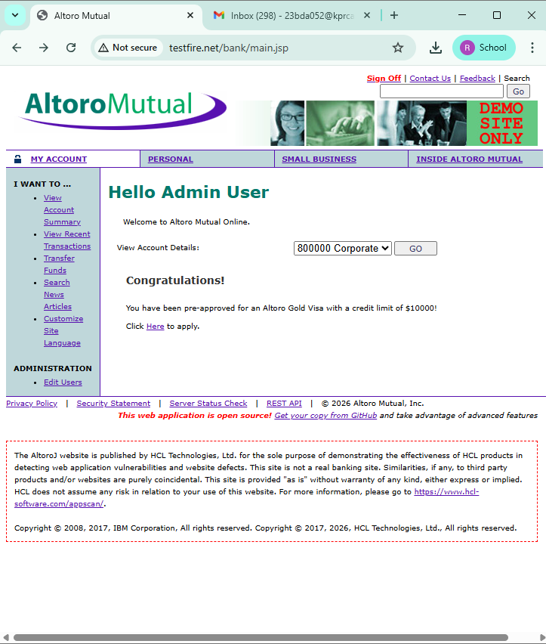
Screenshot:
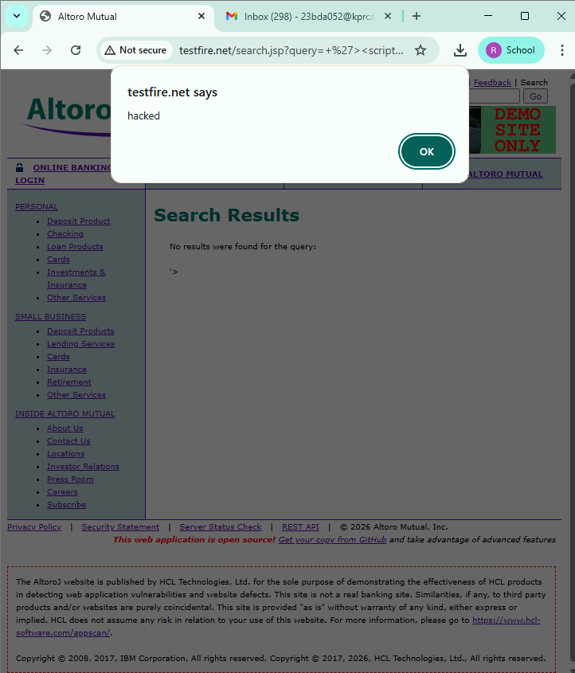

- Vulnerability Name : Broken Access Control
CWE No : CWE-285
Description : Broken Access Control occurs when a system does not properly restrict users from accessing data or functions that they are not authorized to use.
Business Impact : Attackers may gain unauthorized access to sensitive data, modify user information, or perform administrative actions.
Vulnerability Path : http://testfire.net/login.jsp
Steps to Reproduce :
- Open the website http://testfire.net/.
- Try logging in using admin credentials.
- Capture the request using Burp Suite.
- The request shows username and password in clear text.
Recommendation :
Implement strong authentication and authorization mechanisms.
Use secure session management to protect user access.
Screenshot :
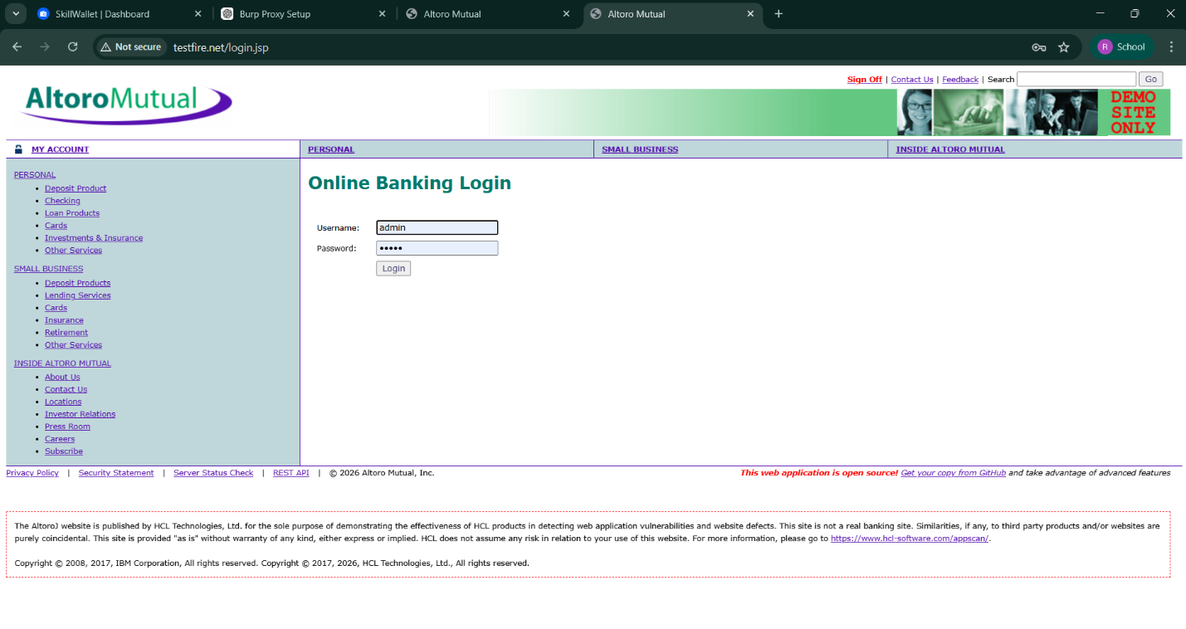

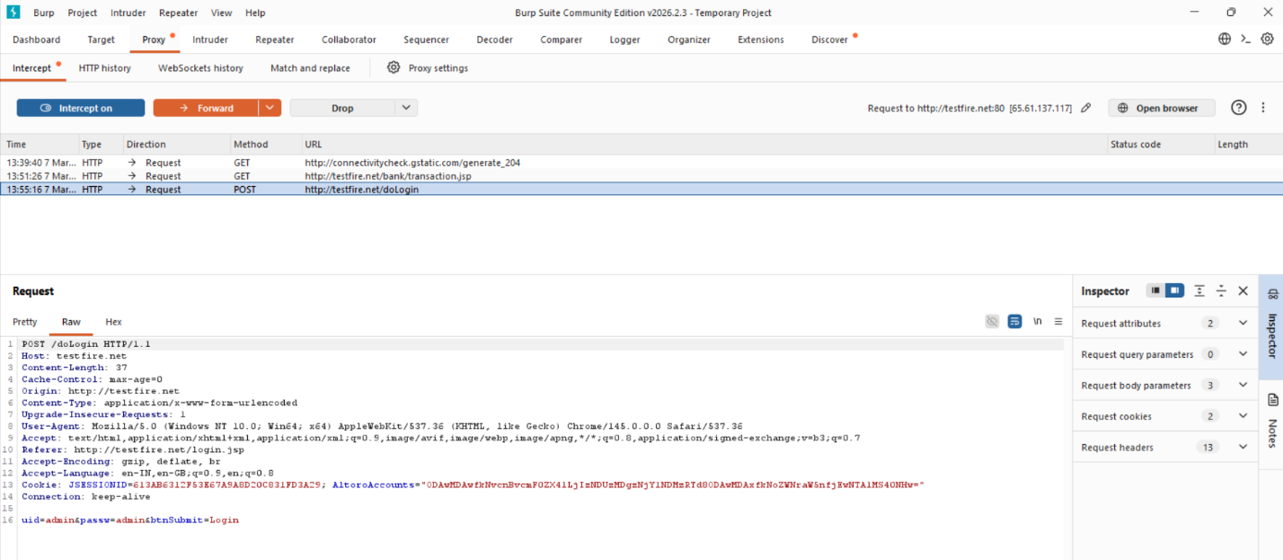
- Vulnerability Name : SQL Injection
CWE No : CWE-89
Description : SQL Injection occurs when an attacker inserts malicious SQL queries into input fields to manipulate the database.
Business Impact : Attackers can access sensitive data, modify database records, or gain unauthorized administrative access.
Vulnerability Path : http://testfire.net/login.jsp
Steps to Reproduce :
- Open the website http://testfire.net/.
- Enter SQL injection payload in the login form.
- Capture the request using Burp Suite.
- The attacker may gain admin access without a valid password.
Recommendation :
Use parameterized queries or prepared statements.
Validate and sanitize all user inputs.

Screenshot :

- Vulnerability Name : Broken Authentication
CWE No : CWE-285
Description : Broken Authentication occurs when the system fails to properly manage user authentication. Attackers can bypass login mechanisms and access other user accounts.
Business Impact : Attackers may gain unauthorized access to user accounts and sensitive information.
Vulnerability Path : http://testfire.net/login.jsp
Steps to Reproduce :
- Open the website http://testfire.net/.
- Try logging in with manipulated username inputs.
- Use SQL injection to bypass password verification.
- Access to another user account is granted.
Recommendation :
Implement strong authentication mechanisms such as Multi-Factor Authentication (MFA).
Use secure password storage and proper session management.

Screenshot :

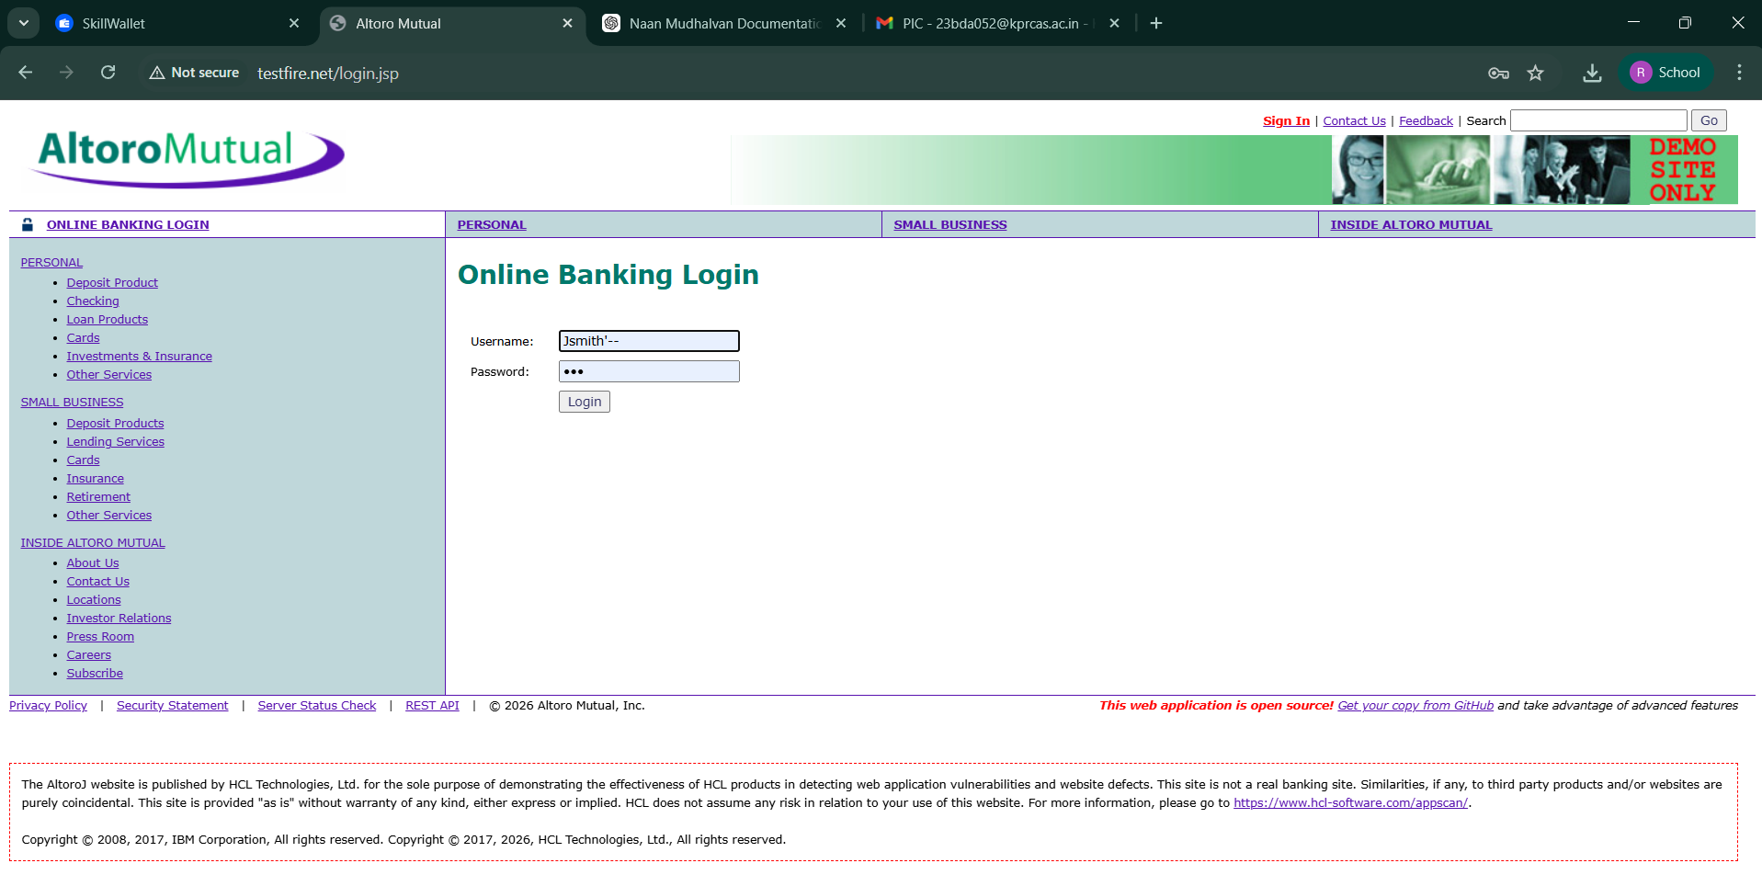

- Vulnerability Name : Insecure Direct Object Reference (IDOR)
CWE No : CWE-639
Description : IDOR occurs when a web application allows users to access or modify data by changing object identifiers such as user IDs or parameters in the URL.
Business Impact : Attackers can access or modify sensitive information of other users without proper authorization.
Vulnerability Path : http://testfire.net/bank/transfer.jsp
Steps to Reproduce :
- Open the website http://testfire.net/.
- Login to the application.
- Go to the “Transfer Money” section.
- Intercept the request using Burp Suite and modify the transfer amount.
Recommendation :
Implement proper access control checks.
Validate user permissions before allowing access to sensitive data.
Screenshot :
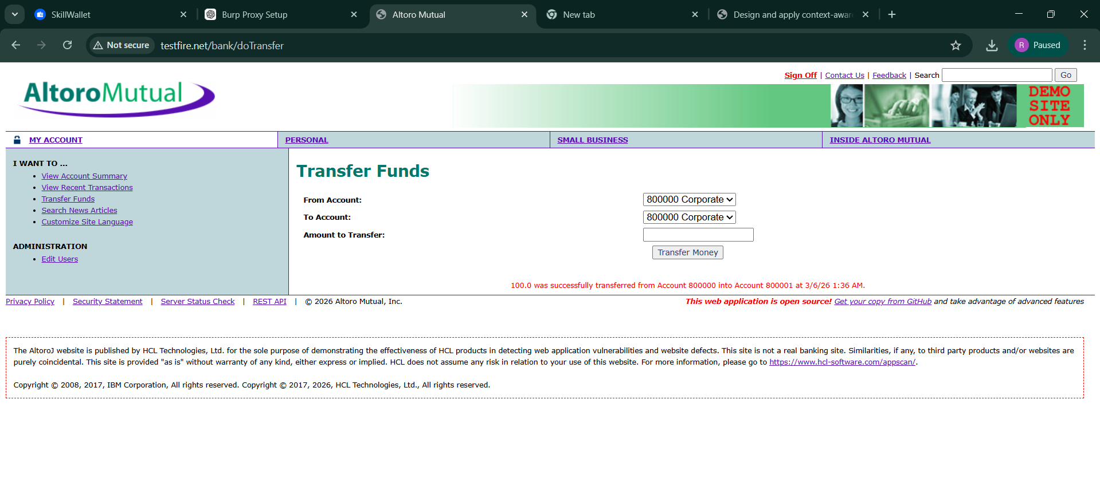
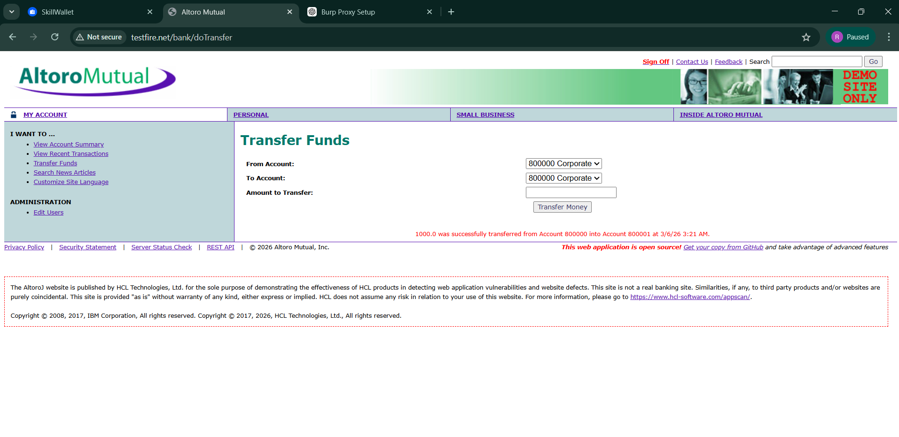
- Vulnerability Name : Security Misconfiguration
CWE No : CWE-732
Description : Security Misconfiguration occurs when systems are not securely configured, allowing unauthorized access to sensitive files or directories.
Business Impact : Attackers may access confidential information, system files, or hidden directories due to weak security settings.
Vulnerability Path : http://testfire.net/

Steps to Reproduce :
- Open the website http://testfire.net/.
- Use scanning tools such as Uniscan in Kali Linux.
- Scan the website for hidden directories.
- The scan reveals accessible directories and sensitive files.
Recommendation :
Apply secure configuration settings for servers and applications.
Regularly perform security audits and vulnerability scans.
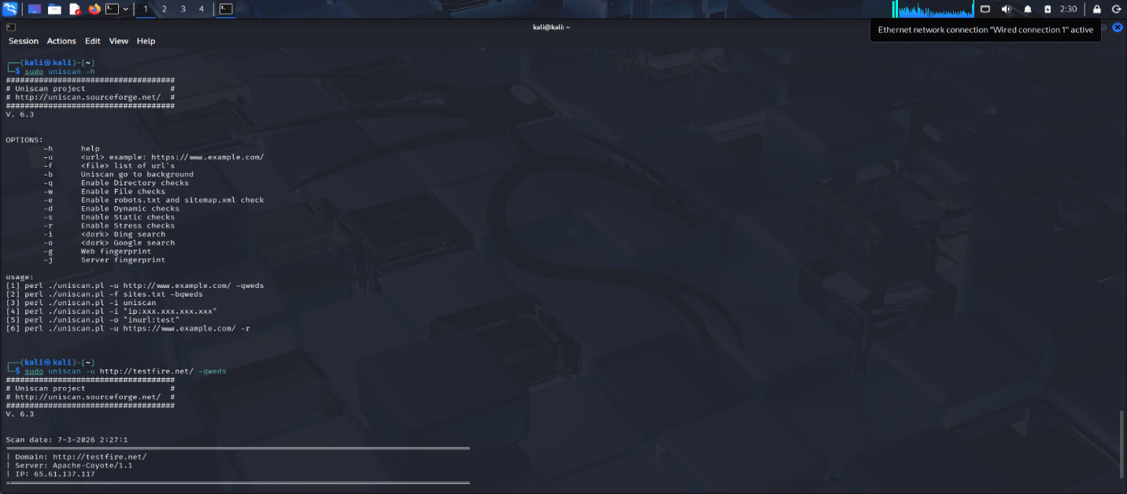
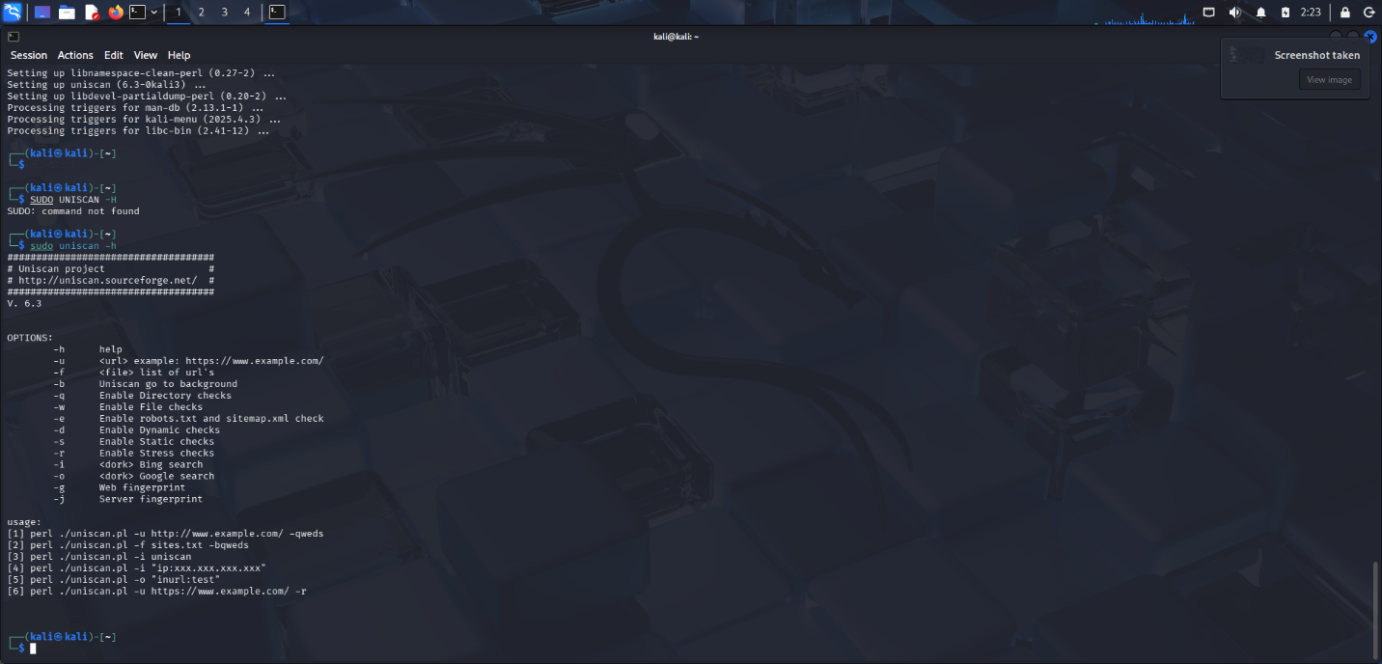
Screenshot :

- Vulnerability Name : Cross-Site Request Forgery (CSRF)
CWE No : CWE-352
Description : CSRF is an attack that tricks a logged-in user into performing unwanted actions on a web application without their knowledge.
Business Impact : Attackers can perform actions such as transferring funds or changing user data using the victim’s authenticated session.
Vulnerability Path : http://testfire.net/bank/transfer.jsp
Steps to Reproduce :
- Open the website http://testfire.net/.
- Login using valid credentials.
- Capture the transfer request using Burp Suite.
- Generate a CSRF proof-of-concept request to perform the action.
Recommendation :
Implement CSRF tokens to validate requests.
Use secure session management techniques.
Screenshot :
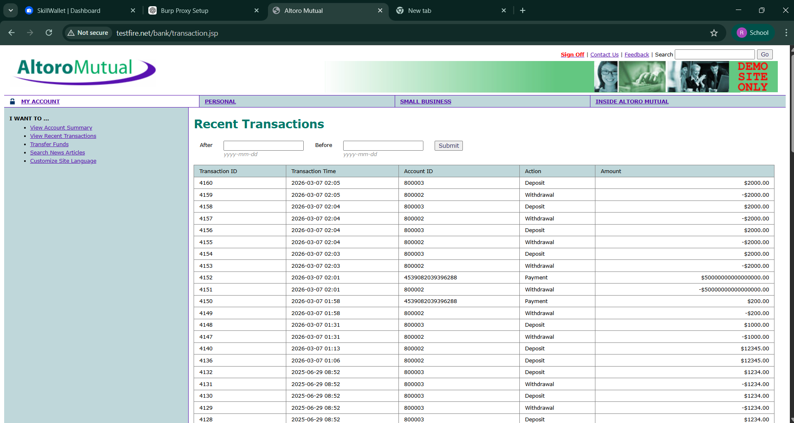

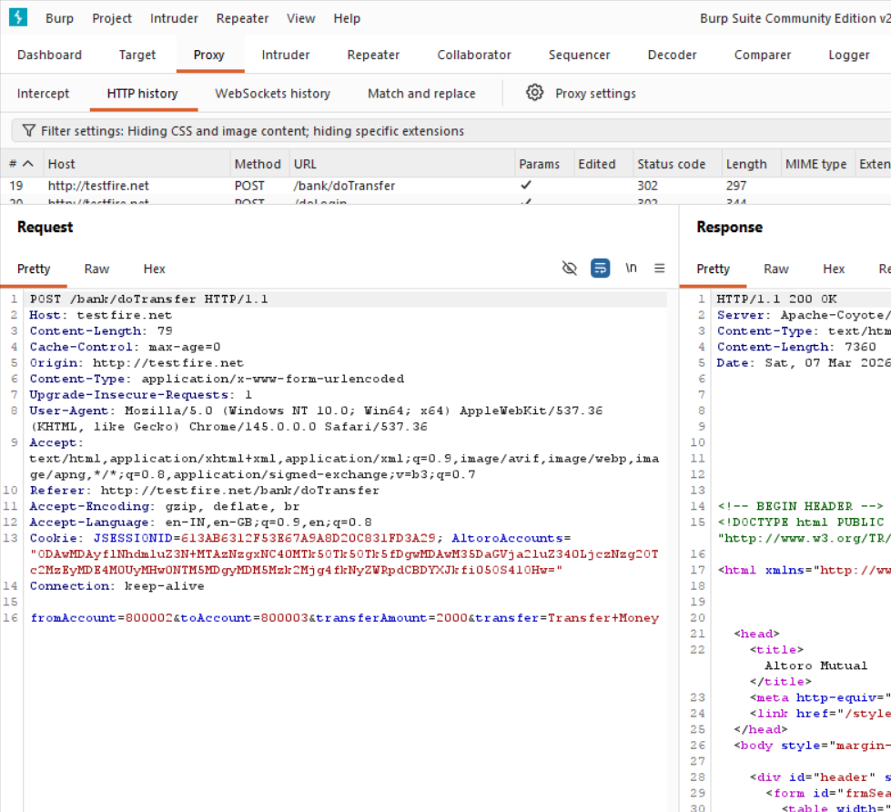
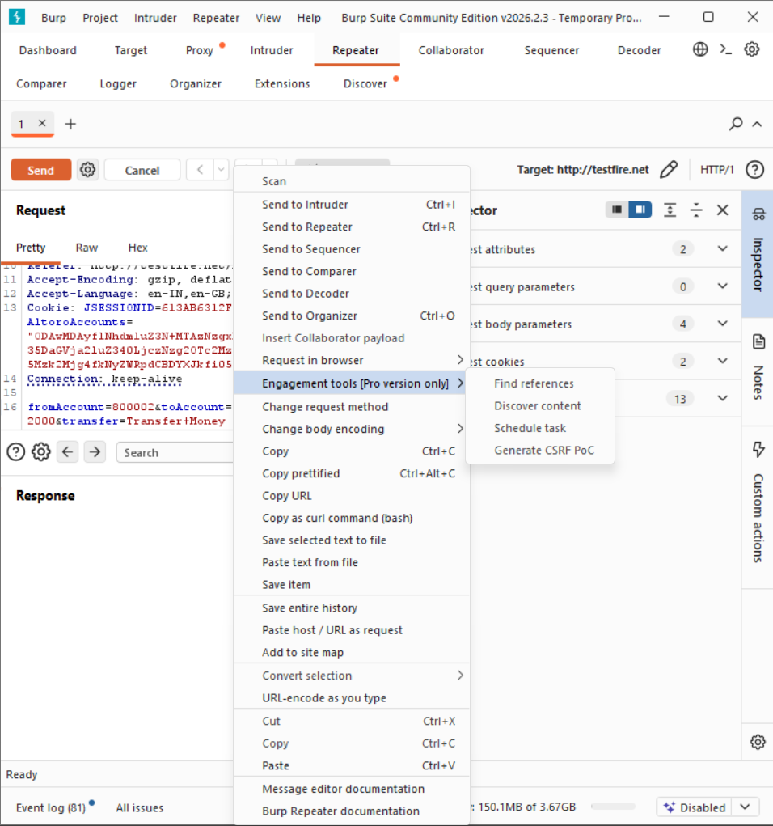

- Vulnerability Name : Cleartext Transmission of Sensitive Information
CWE No : CWE-319
Description : This vulnerability occurs when sensitive information such as usernames and passwords is transmitted without encryption over the network.
Business Impact : Attackers can intercept network traffic and capture sensitive information, leading to data breaches and unauthorized access.
Vulnerability Path : http://testfire.net/login.jsp
Steps to Reproduce :
- Open the website http://testfire.net/.
- Login using admin credentials.
- Capture the request using Burp Suite.
- The username and password appear in clear text in the request.
Recommendation :
• Use HTTPS with SSL/TLS encryption.
• Ensure sensitive data is always transmitted securely.
Screenshot :


- Vulnerability Name : Clickjacking
CWE No : CWE-1021
Description : Clickjacking occurs when a malicious webpage tricks users into clicking hidden buttons or links by placing the target webpage inside an invisible frame.
Business Impact : Attackers can trick users into performing unwanted actions such as clicking buttons, submitting forms, or revealing sensitive information.
Vulnerability Path : http://testfire.net/
Steps to Reproduce :
- Open the target website http://testfire.net/.
- Create an HTML page that loads the site inside an iframe.
- Run the HTML file in a browser.
- The website loads inside the frame, confirming the vulnerability.
Recommendation :
Use X-Frame-Options header to prevent framing.
Implement Content Security Policy (CSP) to block unauthorized embedding.
Screenshot :
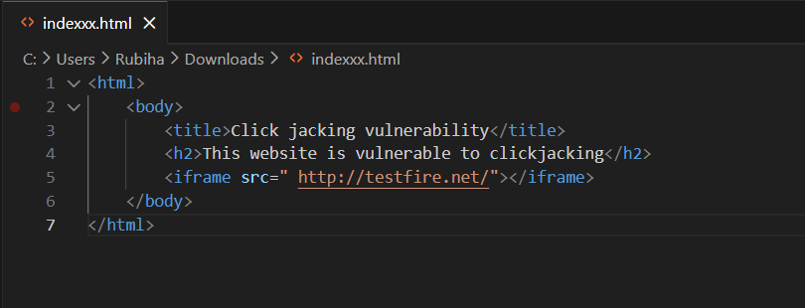
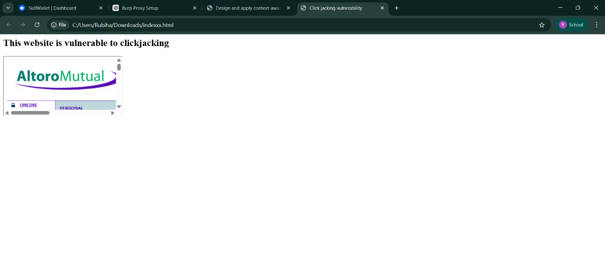
- Vulnerability Name : Web Server Allows Password Auto-Completion
CWE No : CWE-310SSS
Description : This vulnerability occurs when the web browser automatically fills previously saved usernames and passwords on login pages.
Business Impact : Attackers who gain access to the device can easily view or use stored credentials to access the application.
Vulnerability Path : http://testfire.net/login.jsp
Steps to Reproduce :
- Open the website http://testfire.net/.
- Navigate to the login page.
- Click on the username or password field.
- The browser automatically suggests stored credentials.
Recommendation :
Disable password auto-completion on login forms.
Use secure authentication mechanisms.

Screenshot :
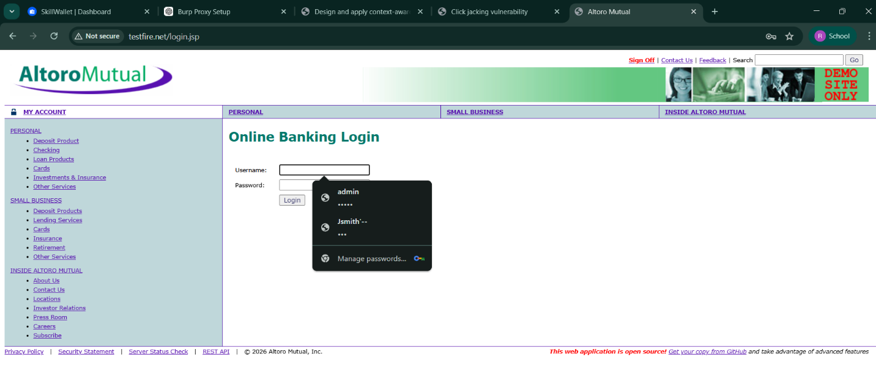
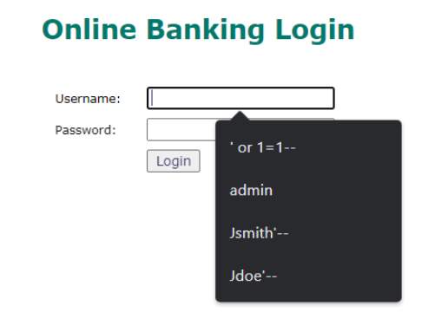
- Vulnerability Name : Cross-Site Scripting (DOM Based)
CWE No : CWE-79
Description : DOM-based XSS occurs when the client-side script processes user input and inserts it into the webpage without proper validation.
Business Impact : Attackers can execute malicious scripts in the user's browser and steal sensitive data such as session cookies.
Vulnerability Path : https://vit.ac.in/
Steps to Reproduce :
- Open the website https://vit.ac.in/.
- Inspect the page source using browser developer tools.
- Identify places where user input is processed by JavaScript.
- Inject malicious scripts to test for DOM manipulation.
Recommendation :
Validate and sanitize user inputs.
Avoid unsafe DOM manipulation methods.
Screenshot :

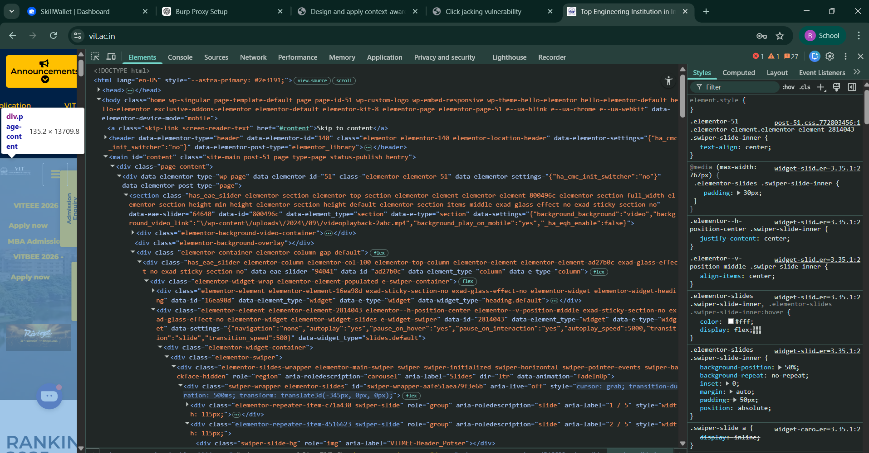

- Vulnerability Name : JQuery Multiple XSS
CWE No : CWE-79
Description : This vulnerability occurs when outdated versions of JQuery contain security flaws that allow attackers to execute malicious scripts.
Business Impact : Attackers can exploit these vulnerabilities to run harmful scripts in the user's browser and steal sensitive data.
Vulnerability Path : https://vit.ac.in/sites/all/themes/vittheme/js/jquery-2.1.1.min.js
Steps to Reproduce :
Open the website https://vit.ac.in/.
Access the JQuery script used by the website.
Identify the JQuery version in the source code.
Older JQuery versions may contain XSS vulnerabilities.
Recommendation :
Update JQuery to the latest secure version.
Regularly update libraries used in web applications.
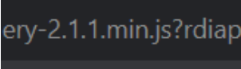
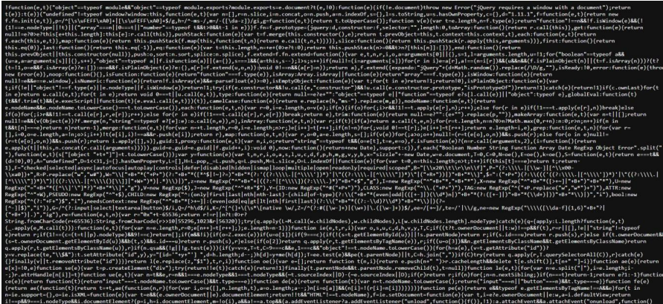
Screenshot :

- Vulnerability Name : Information Exposure (Web Server HTTP Header Internal IP Disclosure)
CWE No : CWE-200
Description : This vulnerability occurs when the web server reveals internal IP addresses or system information in HTTP response headers.
Business Impact : Attackers can use this internal information to identify the system structure and plan further attacks on the network.
Vulnerability Path : https://vit.ac.in/
Steps to Reproduce :
- Open the target website.
- Scan the website using Nessus vulnerability scanner.
- Analyze the HTTP response headers.
- The scan reveals the internal IP address of the server.
Recommendation :
Configure the web server to hide internal IP addresses.
Remove unnecessary information from HTTP response headers.
Screenshot :
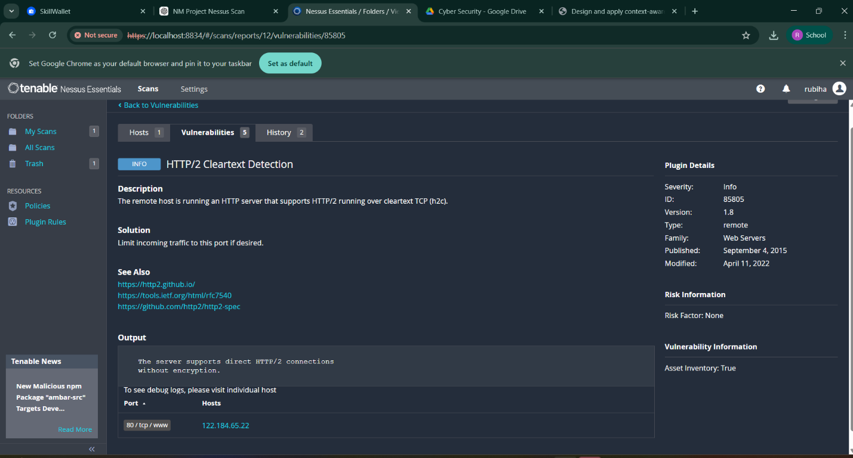
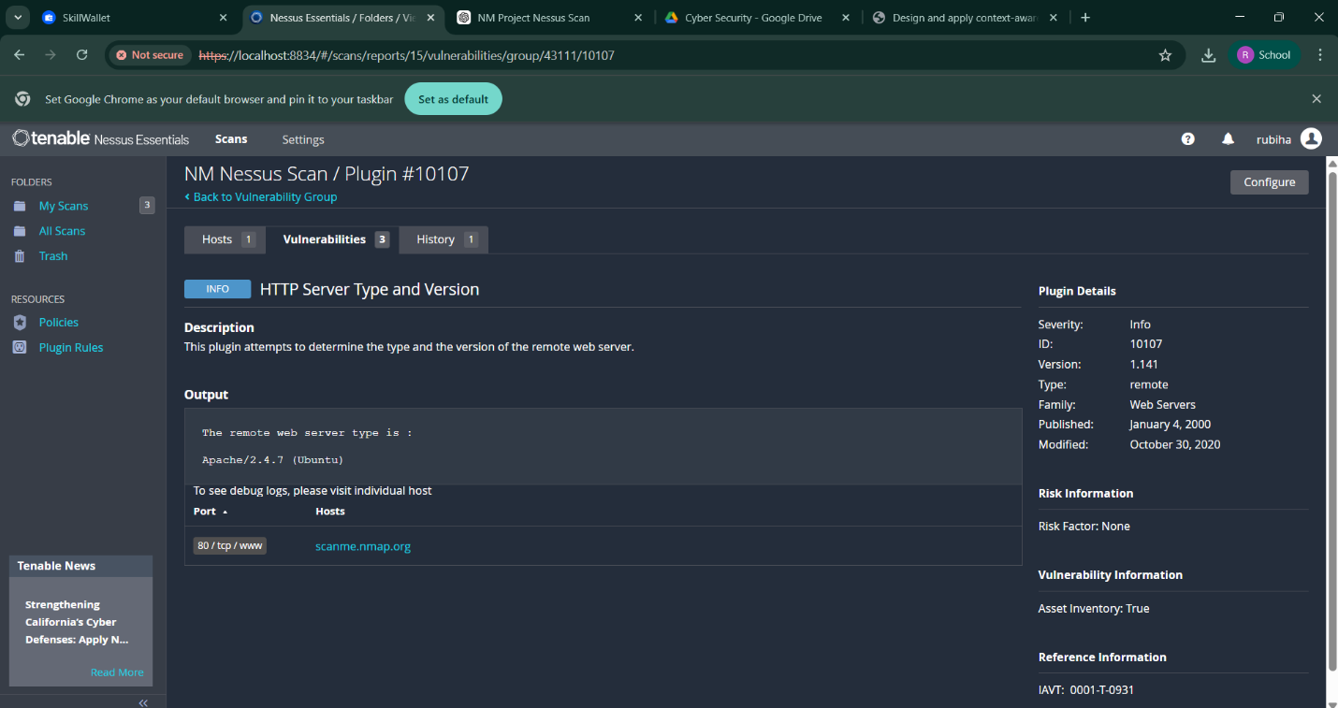
- Vulnerability Name : Information Exposure (SSL Multiple Issues)
CWE No : CWE-200
Description : This vulnerability occurs when the SSL/TLS configuration of a website exposes sensitive encryption details or uses weak security protocols.
Business Impact : Weak SSL configurations can allow attackers to intercept encrypted communication and access sensitive data.
Vulnerability Path : https://vit.ac.in/
Steps to Reproduce :
- Open the target website.
- Scan the website using Nessus vulnerability scanner.
- Analyze the SSL/TLS configuration details.
- The scan shows issues related to encryption protocols.
Recommendation :
Use strong encryption protocols such as TLS 1.2 or higher.
Disable outdated protocols like SSLv3.

Screenshot :
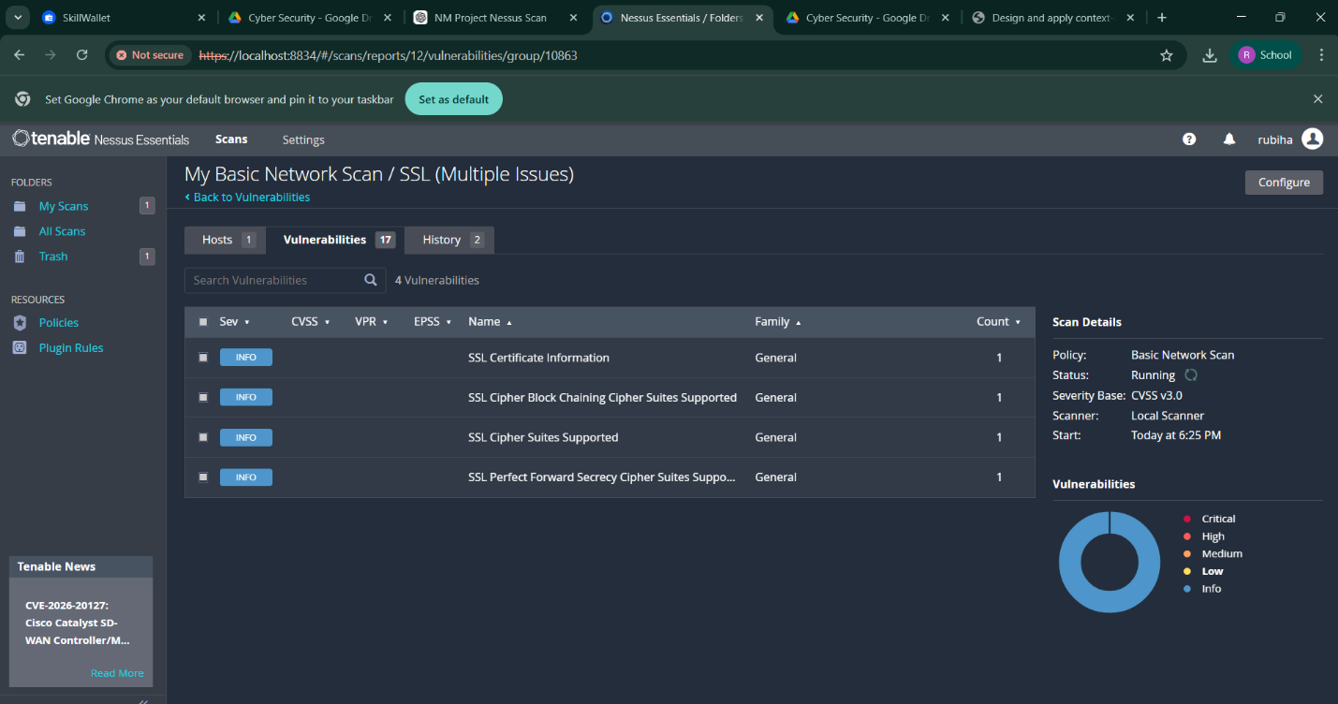
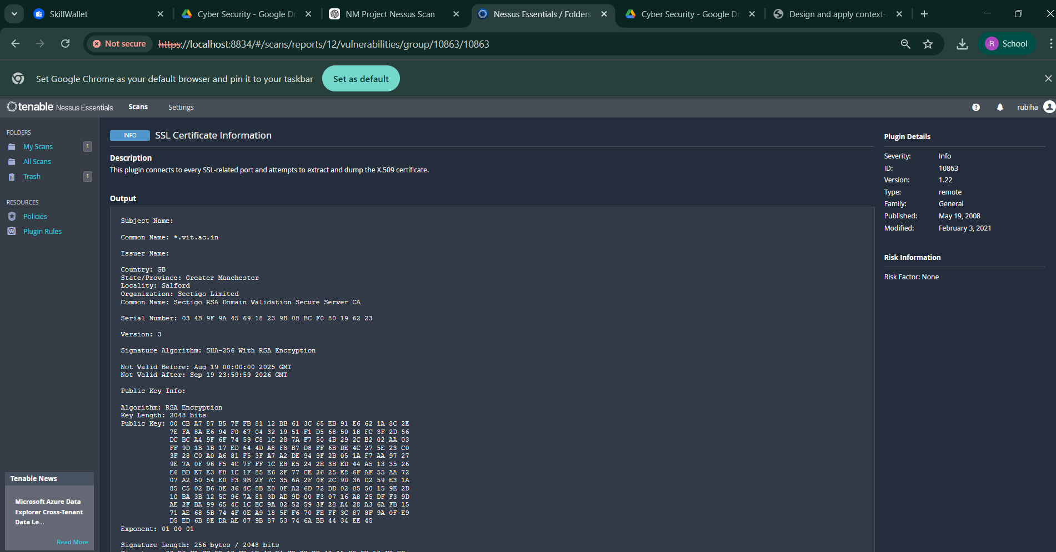

- Vulnerability Name : Information Exposure (HTTP Multiple Issues)
CWE No : CWE-200
Description : This vulnerability occurs when the web server reveals unnecessary information through HTTP responses such as server details and protocol information.
Business Impact : Attackers can gather system information which may help them identify weaknesses and launch further attacks.
Vulnerability Path : https://vit.ac.in/
Steps to Reproduce :
- Open the target website.
- Scan the website using Nessus scanner.
- Review the HTTP response details.
- The scan reveals server information and protocol details.
Recommendation :
Reduce unnecessary information in HTTP responses.
Use secure HTTPS configuration for communication.
Screenshot :
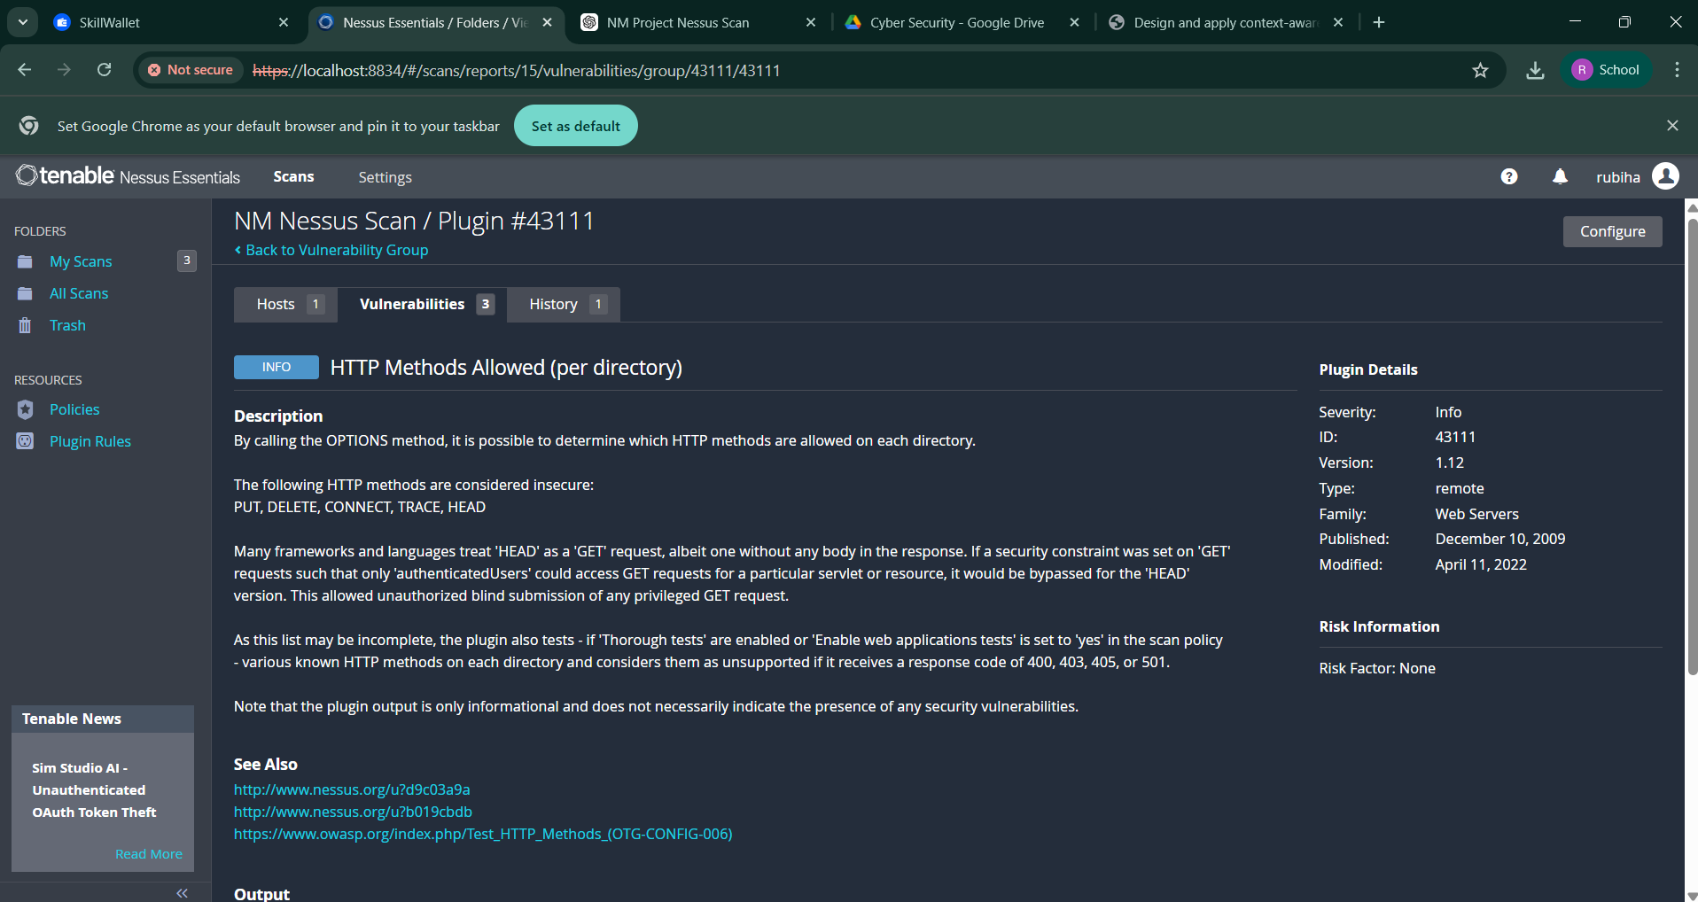

- Vulnerability Name : OS Identification Failed
CWE No : CWE-200
Description : OS Identification Failed occurs when a vulnerability scanning tool cannot accurately detect the operating system of the target server.
Business Impact : Incorrect system identification may lead to improper security analysis and may hide potential vulnerabilities in the system.
Vulnerability Path : https://vit.ac.in/
Steps to Reproduce :
- Open the target website.
- Perform a vulnerability scan using Nessus scanner.
- Analyze the scan results.
- The scanner fails to identify the operating system of the target server.
Recommendation :
Ensure proper system configuration for accurate scanning.
Perform regular vulnerability assessments to detect security issues.
Screenshot :
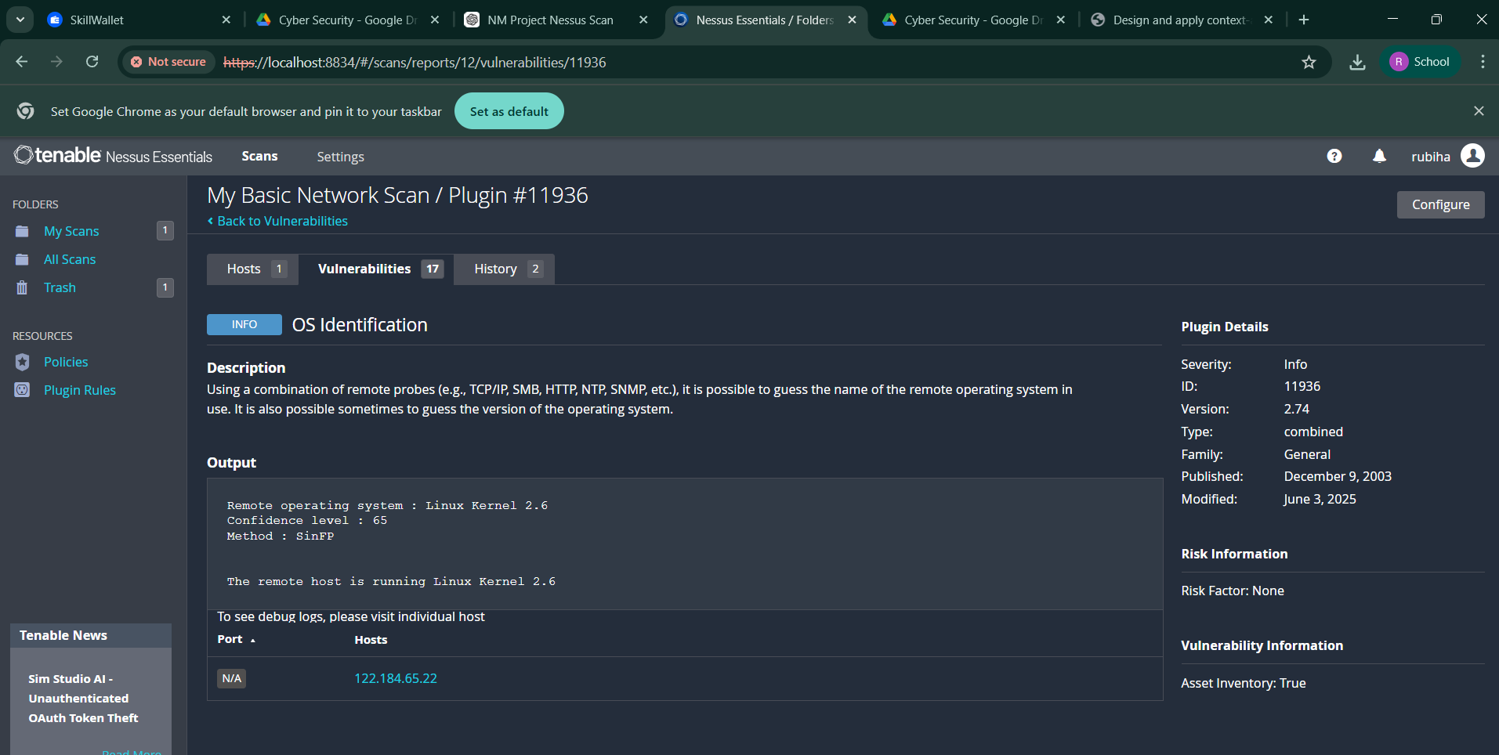

STAGE 2
OVERVIEW
In this stage, vulnerability scanning and security analysis were performed to identify potential security weaknesses in the target web application. The main objective of this stage is to detect vulnerabilities that could allow attackers to gain unauthorized access, expose sensitive information, or disrupt system functionality.
To perform the security assessment, a vulnerability scanning tool called Tenable Nessus was used. Nessus is one of the most widely used cybersecurity tools for identifying vulnerabilities in systems, networks, and web applications. The scanner analyzes the target system and detects possible security flaws such as outdated software, configuration issues, injection vulnerabilities, and information exposure problems.
The scanning process provides detailed information about each vulnerability including its severity level, plugin ID, affected ports, description, and recommended solutions. By analyzing these results, organizations can understand the security posture of their systems and take corrective actions to improve their cybersecurity defenses.
The following table shows the vulnerabilities identified during the Nessus vulnerability scanning process.
TENABLE NESSUS EXPLANATION
Tenable Nessus is a vulnerability scanning tool used by security professionals to identify security weaknesses in computer systems, networks, and web applications.
Nessus works by scanning the target host using thousands of vulnerability plugins. These plugins check for known security issues such as misconfigurations, outdated software, exposed services, and potential attack vectors.
The tool generates detailed reports that include vulnerability severity levels, affected ports, technical descriptions, and recommended remediation steps.

Key Features of Tenable Nessus:
- Performs automated vulnerability scanning
- Detects security misconfigurations
- Identifies outdated software and libraries
- Provides risk severity levels (Critical, High, Medium, Low, Info)
- Generates detailed vulnerability reports
- Helps organizations improve their security posture
By using Nessus, organizations can proactively detect vulnerabilities and fix them before attackers exploit them.
In this stage, vulnerability scanning and security analysis were performed to identify potential security weaknesses in the target web application. The objective of this stage is to detect vulnerabilities that may allow attackers to gain unauthorized access or expose sensitive information.
Security testing was conducted using vulnerability assessment tools such as Nessus Scanner along with manual analysis techniques. These tools help in scanning the web server, identifying vulnerabilities, and analyzing the security posture of the application.
The scan results provide information about different types of vulnerabilities along with their severity levels. The identified issues include Cross-Site Scripting, information exposure, and configuration-related vulnerabilities.
The following table shows the vulnerabilities detected during the scanning process.
S. No | Vulnerability Name | Severity | Plugin
1 | Cross-Site Scripting (DOM Based XSS) | Medium | Multiple XSS
2 | jQuery 1.3 < 3.5.0 Multiple XSS | Medium | CGI Abuse: XSS
3 | Information Exposure (Web Server HTTP Header Internal IP Disclosure) | Low | Webserver HTTP Header Internal IP Disclosure
4 | Information Exposure (SSL Multiple Issues) | Info | SSL Certificate Information
5 | Information Exposure (HTTP Multiple Issues) | Info | HTTP Information
6 | OS Identification Failed | Info | TCP/IP Remote Probing

1. Cross-Site Scripting (DOM Based XSS)
Plugin: Multiple XSS
Port: 80 / 443
Description: DOM-based Cross-Site Scripting (XSS) occurs when user input is processed directly in the browser using JavaScript without proper validation. Attackers can inject malicious scripts that execute in the victim's browser. These scripts may manipulate the webpage or steal sensitive information.
Solution:
Validate and sanitize all user inputs.
Avoid unsafe JavaScript functions.
Implement secure coding practices.
Business Impact: Attackers may steal session cookies, redirect users to malicious websites, or perform actions on behalf of the user.

2. jQuery 1.3 < 3.5.0 Multiple XSS

Plugin: CGI Abuse: XSS
Port: 80
Description: This vulnerability occurs when websites use outdated versions of the jQuery library. Older versions contain security flaws that allow attackers to execute Cross-Site Scripting attacks.
Solution:
Update jQuery to the latest version.
Regularly update third-party libraries.
Business Impact: Attackers may exploit the vulnerability to execute malicious scripts and compromise user data.

3. Information Exposure (Web Server HTTP Header Internal IP Disclosure)

Plugin: Web Server HTTP Header Internal IP Disclosure
Port: 80 / 443
Description: The web server exposes internal IP addresses through HTTP response headers. This information can reveal internal network details.
Solution:
Hide internal IP addresses in server headers.
Configure secure server settings.
Business Impact: Attackers can use internal information to plan further attacks on the network.

4.Information Exposure (SSL Multiple Issues)
Plugin: SSL Certificate Information
Port: 443
Description: The SSL/TLS configuration of the server reveals encryption details or uses outdated protocols.
Solution:
Use strong encryption protocols such as TLS 1.2 or TLS 1.3.
Disable insecure SSL protocols.
Business Impact: Weak encryption may allow attackers to intercept sensitive communication.
5. Information Exposure (HTTP Multiple Issues)
Plugin: HTTP Information
Port: 80
Description: The web server exposes unnecessary information such as server details and configuration through HTTP responses.
Solution:
Remove unnecessary HTTP headers.
Configure the web server securely.
Business Impact: Attackers can gather system information and exploit vulnerabilities.

6. OS Identification Failed
Plugin: TCP/IP Remote Probing
Port: General
Description: This issue occurs when the vulnerability scanner cannot determine the operating system of the target host.
Solution:
Configure systems properly for accurate scanning.
Perform regular vulnerability assessments.
Business Impact: Incorrect OS identification may limit accurate vulnerability detection.

7. SQL Injection
Plugin: SQL Injection Vulnerability
Port: 80
Description: SQL Injection occurs when attackers insert malicious SQL queries into input fields to manipulate the database.
Solution:
Use parameterized queries or prepared statements.
Validate and sanitize user inputs.
Business Impact: Attackers may access confidential data, modify database records, or gain unauthorized access.

8. Security Misconfiguration
Plugin: Web Server Misconfiguration
Port: 80 / 443
Description: Security Misconfiguration occurs when systems are configured improperly, allowing unauthorized access to files or directories.
Solution:
Apply secure server configurations.
Perform regular security audits.
Business Impact: Attackers may access confidential data or system files.

9. Cross-Site Request Forgery (CSRF)
Plugin: CSRF Detection
Port: 80 / 443
Description: CSRF attacks trick users into performing actions on a web application without their consent.
Solution:
Implement CSRF tokens.
Use secure session management.
Business Impact: Attackers may perform unauthorized actions such as changing data or transferring funds.

10. Cleartext Transmission of Sensitive Information
Plugin: Sensitive Information Disclosure
Port: 80
Description: Sensitive information such as usernames and passwords is transmitted without encryption.
Solution:
Use HTTPS with SSL/TLS encryption.
Avoid sending sensitive data through unsecured connections.
Business Impact: Attackers can intercept network traffic and steal sensitive information.

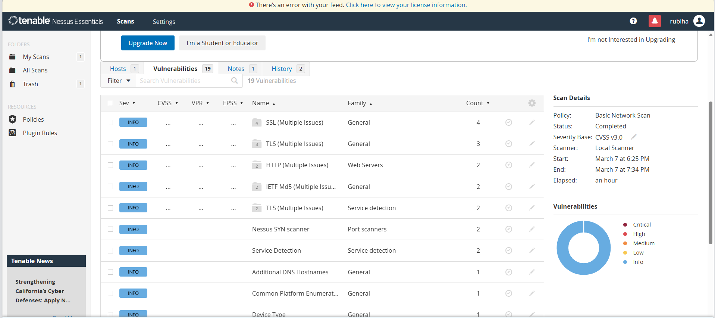
STAGE 3
Title: Security Operations Center (SOC) Implementation and Threat Intelligence Integration for Cybersecurity Monitoring
SOC (SECURITY OPERATIONS CENTER)
A Security Operations Center (SOC) is a centralized facility where cybersecurity professionals monitor, detect, analyze, and respond to security incidents in real time. The main objective of SOC is to protect an organization’s IT infrastructure from cyber threats and attacks.
SOC teams continuously monitor network traffic, system activities, and security alerts to identify suspicious behavior. They use advanced security tools such as SIEM systems, intrusion detection systems, and threat intelligence platforms to analyze and respond to threats.
SOC plays a crucial role in improving the overall cybersecurity posture of an organization by providing continuous monitoring, quick incident response, and proactive threat detection.
Key Responsibilities of SOC:
Continuous monitoring of network activities.
Detecting security threats and vulnerabilities.
Incident response and threat mitigation.
Security event analysis and reporting.
Managing security tools and technologies.
SOC CYCLE
The SOC operates through a continuous security monitoring cycle that ensures effective detection and response to cyber threats.
Steps in SOC Cycle:
- Monitoring
Continuous monitoring of network traffic, logs, and system activities to detect unusual behavior.
- Detection
Identifying potential security threats and suspicious activities using security tools.
- Analysis
Security analysts investigate alerts to determine whether they represent real threats.
- Response
Immediate action is taken to contain and mitigate the detected threat.
- Recovery
Systems are restored to normal operations after resolving the security incident.
- Improvement
Security policies and detection rules are updated to prevent similar attacks in the future.
SIEM (SECURITY INFORMATION AND EVENT MANAGEMENT)
SIEM is a security solution that collects, analyzes, and manages security data from various sources such as servers, network devices, and applications.
SIEM tools gather logs and events from multiple systems and analyze them in real time to detect suspicious activities. These tools help security teams quickly identify potential cyber threats and respond to security incidents.
SIEM provides centralized visibility of security events and helps organizations improve threat detection and incident response.
Examples of SIEM Tools:
• Splunk
• IBM QRadar
• ArcSight
• LogRhythm
SIEM CYCLE
The SIEM system operates through a structured process for managing security events.
- Data Collection
Logs and security events are collected from servers, network devices, and applications.
- Data Normalization
The collected data is converted into a standard format for easier analysis.
- Correlation
Security events are analyzed and correlated to identify potential threats.
- Alert Generation
The system generates alerts when suspicious activity is detected.
- Incident Response
Security teams investigate alerts and respond to security incidents.
MISP (MALWARE INFORMATION SHARING PLATFORM)
MISP is an open-source threat intelligence platform used to collect, store, and share cybersecurity threat information between organizations.
MISP helps security teams share information about malware, cyber attacks, vulnerabilities, and threat actors. By sharing threat intelligence, organizations can detect attacks early and strengthen their security defenses.
Key Features of MISP:
• Threat intelligence sharing
• Malware analysis support
• Incident tracking
• Collaboration between security teams
OUR COLLEGE NETWORK INFORMATION
The college network consists of multiple interconnected systems including student computers, faculty systems, servers, and internet connectivity. The network infrastructure includes routers, switches, and firewalls to manage communication between devices.
The college network provides services such as:
• Internet access for students and faculty
• Online learning platforms
• College websites and portals
• Database systems for academic records
Protecting the college network from cyber threats is essential to ensure the confidentiality, integrity, and availability of information.
HOW DO I THINK I DEPLOY MY PROJECT
The project can be deployed in the college network environment to enhance cybersecurity monitoring and vulnerability detection.
The deployment process includes the following steps:
- Install vulnerability scanning tools such as Nessus.
- Configure network monitoring systems to analyze traffic.
- Implement SIEM tools to collect and analyze security logs.
- Integrate threat intelligence platforms such as MISP.
- Monitor network activities through the SOC environment.
This deployment will help detect vulnerabilities, monitor security events, and improve the security of the college network.
THREAT INTELLIGENCE:
Threat intelligence refers to the collection and analysis of information about cyber threats and attackers.
It helps organizations understand potential threats, attack methods, and vulnerabilities. Security teams use threat intelligence to predict attacks and strengthen their security defenses.
Types of Threat Intelligence:
• Strategic Threat Intelligence
• Tactical Threat Intelligence
• Operational Threat Intelligence
• Technical Threat Intelligence
Threat intelligence improves the ability of organizations to detect and prevent cyber attacks.
RESULTS AND SECURITY RECOMMENDATIONS
After completing the vulnerability scanning and analysis process, several security issues were identified in the target web application. The vulnerability assessment was performed using tools such as Nessus Scanner, Burp Suite, and manual testing techniques. The scan results revealed different types of vulnerabilities including Cross-Site Scripting (XSS), outdated JavaScript libraries, information exposure through HTTP headers, and configuration-related issues.
The vulnerability scan categorized the issues into different severity levels such as Medium, Low, and Informational. Medium-level vulnerabilities like DOM-Based Cross-Site Scripting and outdated jQuery versions can allow attackers to execute malicious scripts in the user’s browser. These vulnerabilities can potentially lead to session hijacking, data theft, or unauthorized access.
Low-level vulnerabilities such as HTTP header internal IP disclosure may expose sensitive server details. Attackers can use this information to better understand the system architecture and plan further attacks on the web server.
Informational vulnerabilities including SSL certificate details, HTTP information disclosure, and OS identification failures provide additional information about the server environment. While these vulnerabilities may not directly lead to attacks, they can assist attackers in gathering intelligence about the system.
To improve the overall security of the application, several security recommendations are suggested. Web developers should implement proper input validation and output encoding to prevent injection attacks such as Cross-Site Scripting. Outdated libraries such as older versions of jQuery should be updated to the latest secure versions to eliminate known vulnerabilities.
Additionally, server configuration should be improved by hiding sensitive HTTP headers and internal IP addresses. Secure communication protocols such as HTTPS with strong SSL/TLS encryption should be used to protect data transmitted over the network. Regular security testing and vulnerability scanning should also be performed to identify new threats and ensure continuous protection of the system.
By implementing these security practices, organizations can significantly reduce the risk of cyberattacks and maintain a secure environment for users and applications.
FUTURE SCOPE
The future scope of this project includes improving cybersecurity monitoring and expanding security capabilities.
Possible improvements include:
- Implementing automated threat detection using artificial intelligence
- Integrating advanced SIEM solutions for real-time monitoring
- Expanding threat intelligence sharing using MISP
- Deploying automated incident response systems
- Enhancing network security using Zero Trust architecture
These improvements can further strengthen the cybersecurity infrastructure of organizations.
TOOLS USED
The project involved the use of several cybersecurity tools and technologies to perform vulnerability scanning and security analysis. These tools help security professionals identify weaknesses in web applications and understand potential attack vectors.
Kali Linux : Kali Linux is a penetration testing operating system that contains a large collection of cybersecurity tools used for ethical hacking, vulnerability analysis, and network security testing. It provides an environment for performing security assessments on systems and web applications.
Nessus Vulnerability Scanner : Nessus is a widely used vulnerability scanning tool that detects security flaws, misconfigurations, and outdated software components in servers and web applications. It provides detailed reports that include vulnerability descriptions, severity levels, and remediation recommendations.
Burp Suite : Burp Suite is a web application security testing tool used to intercept, inspect, and modify HTTP requests and responses between the browser and the web server. It helps identify vulnerabilities such as SQL Injection, Cross-Site Scripting, and authentication issues.
Web Browser : A web browser such as Google Chrome or Mozilla Firefox is used to access the target web application and perform manual security testing. Browser developer tools help inspect web page elements and analyze scripts.
Uniscan Tool : Uniscan is a web vulnerability scanning tool used to detect hidden directories, configuration issues, and potential vulnerabilities in web applications.
These tools collectively help security analysts perform effective vulnerability assessments and improve the overall security posture of web applications.
TOOLS EXPLORED
During the project, various cybersecurity tools and technologies were explored to understand modern security practices.

Some of the explored tools include:
- Nmap
- Wireshark
- Metasploit Framework
- OWASP ZAP
- MISP Platform
These tools provide advanced capabilities for network scanning, vulnerability detection, and threat analysis.
CONCLUSION
The main objective of this project was to design and apply context-aware access control concepts while performing vulnerability assessment on web applications. With the rapid growth of digital technologies and online services, cybersecurity has become an essential requirement for protecting sensitive data and system resources.
Through this project, various web application vulnerabilities were identified and analyzed using security testing tools. The vulnerability scanning process helped in understanding how attackers exploit weaknesses in web applications and how these vulnerabilities can impact the security of an organization.
The analysis revealed several vulnerabilities including Cross-Site Scripting, outdated software components, information exposure issues, and configuration weaknesses. Each vulnerability highlights the importance of implementing secure coding practices, proper system configuration, and regular security testing.This project demonstrates the role of vulnerability assessment and security testing in improving application security. By identifying and addressing security weaknesses, organizations can prevent potential cyberattacks, protect user data, and maintain system integrity.
Overall, the project emphasizes the importance of proactive security measures, continuous monitoring, and regular vulnerability scanning to ensure a secure digital environment. Implementing strong security policies and modern access control mechanisms will help organizations protect their systems against evolving cyber threats.

